**Conditionals & While Loop**

**1) Conditional Statements:**

Conditionals statements are used to execute a particular set of code based on certain condition to be true. There are mainly three conditional statements in C++.

1. If Statement
2. If Else Statement
3. If Else-If Statement

**2) If Statement:**

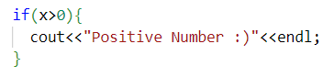

**3) If Else Statement:**

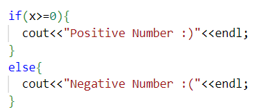

**4) If Else-If Else Statement:**

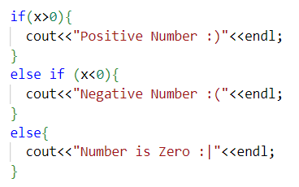

**5) Cin.get() Function:**

Cin keyword does not consider space, tab and enter. To make it consider space, tab and enter we have to use Cin.get() function. Cin.get() function return ASCII value of input data.

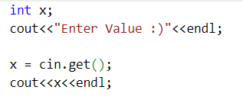

**6) Question 1:**

Write a program to check if the number is positive, negative or zero using conditional statements.

**Solution:**

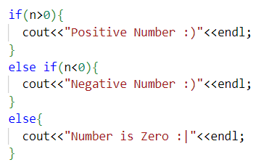

**7) Question 2:**

Write a program to check if the character is uppercase, lowercase, digit or special symbol.

**Solution:**

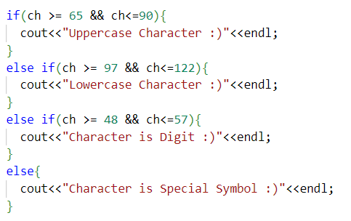

**8) While Loop:**

While loop loops through a block of code as long as a specified condition is true.

**Example:**

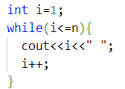

**9) Question 3:**

Write a program to find the sum of first n natural numbers.

**Solution:**

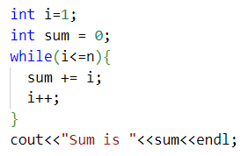

**10) Question 4:**

Write a program to find the sum of first n even natural numbers.

**Solution:**

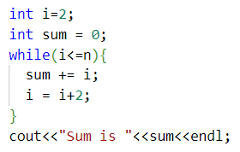

**11) Question 5:**

Write a program to find the factorial of a number.

**Solution:**

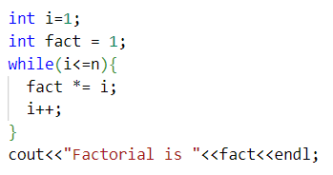

**12) Question 6:**

Write a program to check if the number is prime or not.

**Solution:**

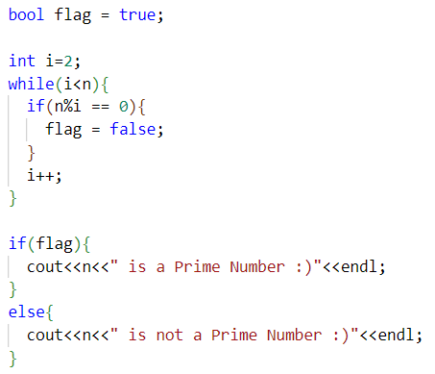

**13) Question 7:**



**Solution:**

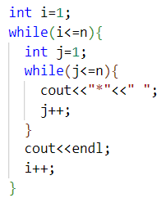

**14) Question 8:**

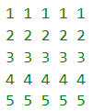

**Solution:**

